**DAILY ONLINE ACTIVITIES SUMMARY**

|  |  |  |  |  |  |
| --- | --- | --- | --- | --- | --- |
| **Date:** | | **25/06/2020** | **Name:** | **JASLINE SHARON TAURO** | |
| **Sem & Sec** | | **4th sem, A Section** | **USN:** | **4AL18CS029** | |
| **Online Test Summary** | | | | | |
| **Subject** | **----** | | | | |
| **Max. Marks** | **----** | | **Score** | **----** | |
| **Certification Course Summary** | | | | | |
| **Course** | | Web Development Engineer | | | |
| **Certificate Provider** | | **AWS Educate** | **Duration** | | **3 hrs.** |
| **Coding Challenges** | | | | | |
| **Problem Statement:**  Write a C Program to reverse the rows in a 2d Array. | | | | | |
| **Status: EXECUTED** | | | | | |
| **Uploaded the report in GitHub** | | | **YES** | | |
| **If yes Repository name** | | | <https://github.com/jaslinesharontauro/C_Prgms> | | |
| **Uploaded the report in slack** | | | **YES** | | |

Online Test Details: (Attach the snapshot and briefly write the report for the same)

Certification Course Details: (Attach the snapshot and briefly write the report for the same)

Coding Challenges Details: (Attach the snapshot and briefly write the report for the same)

CERTIFICATION COURSE DETAILS:

Today I have continued the course “Web Development Engineer” by AWS Educate. In this course today I learnt about ‘Networking-Introduction, Architecture, Troubleshooting, provisioning and Directory service. Today I have completed two modules of this course, And I have also completed the final assessment and project of this course.

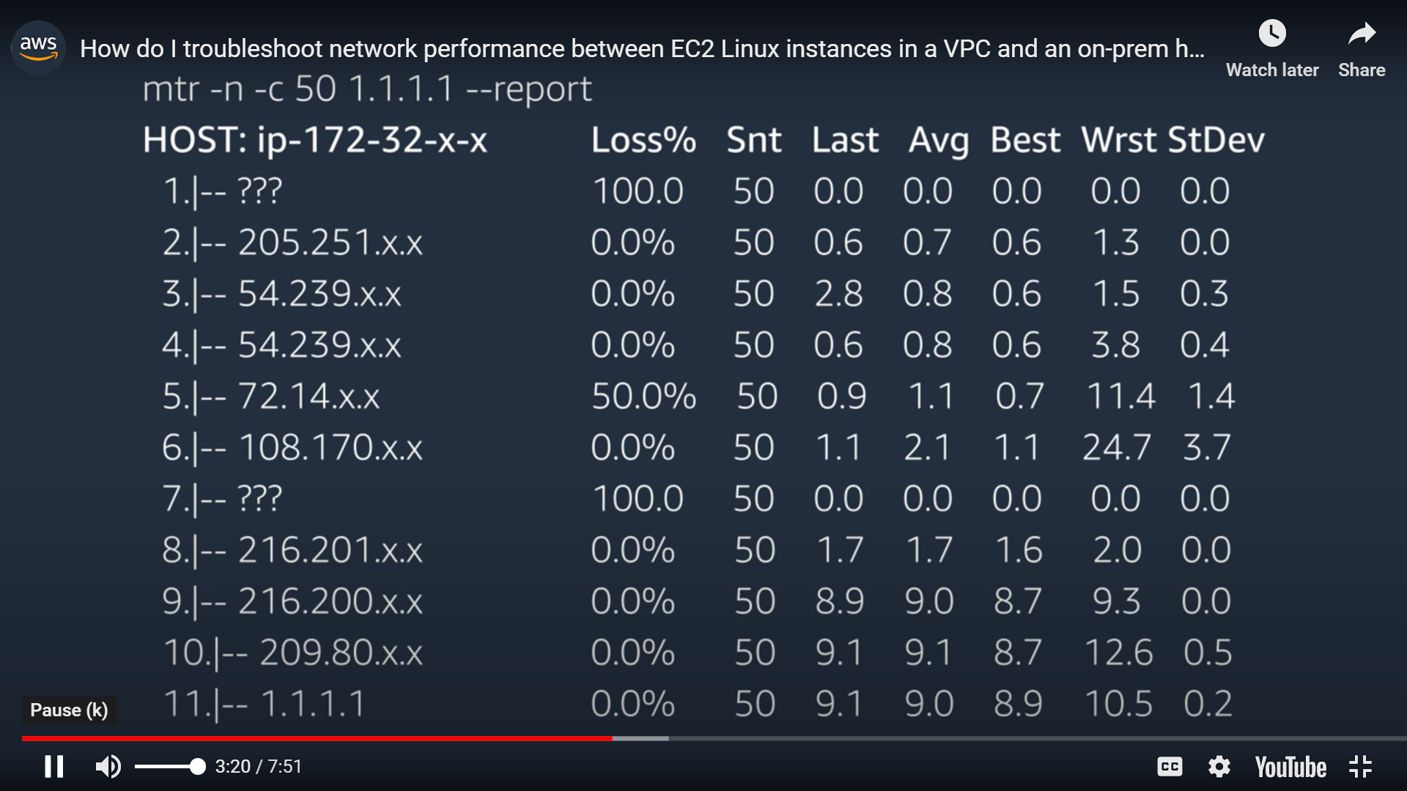

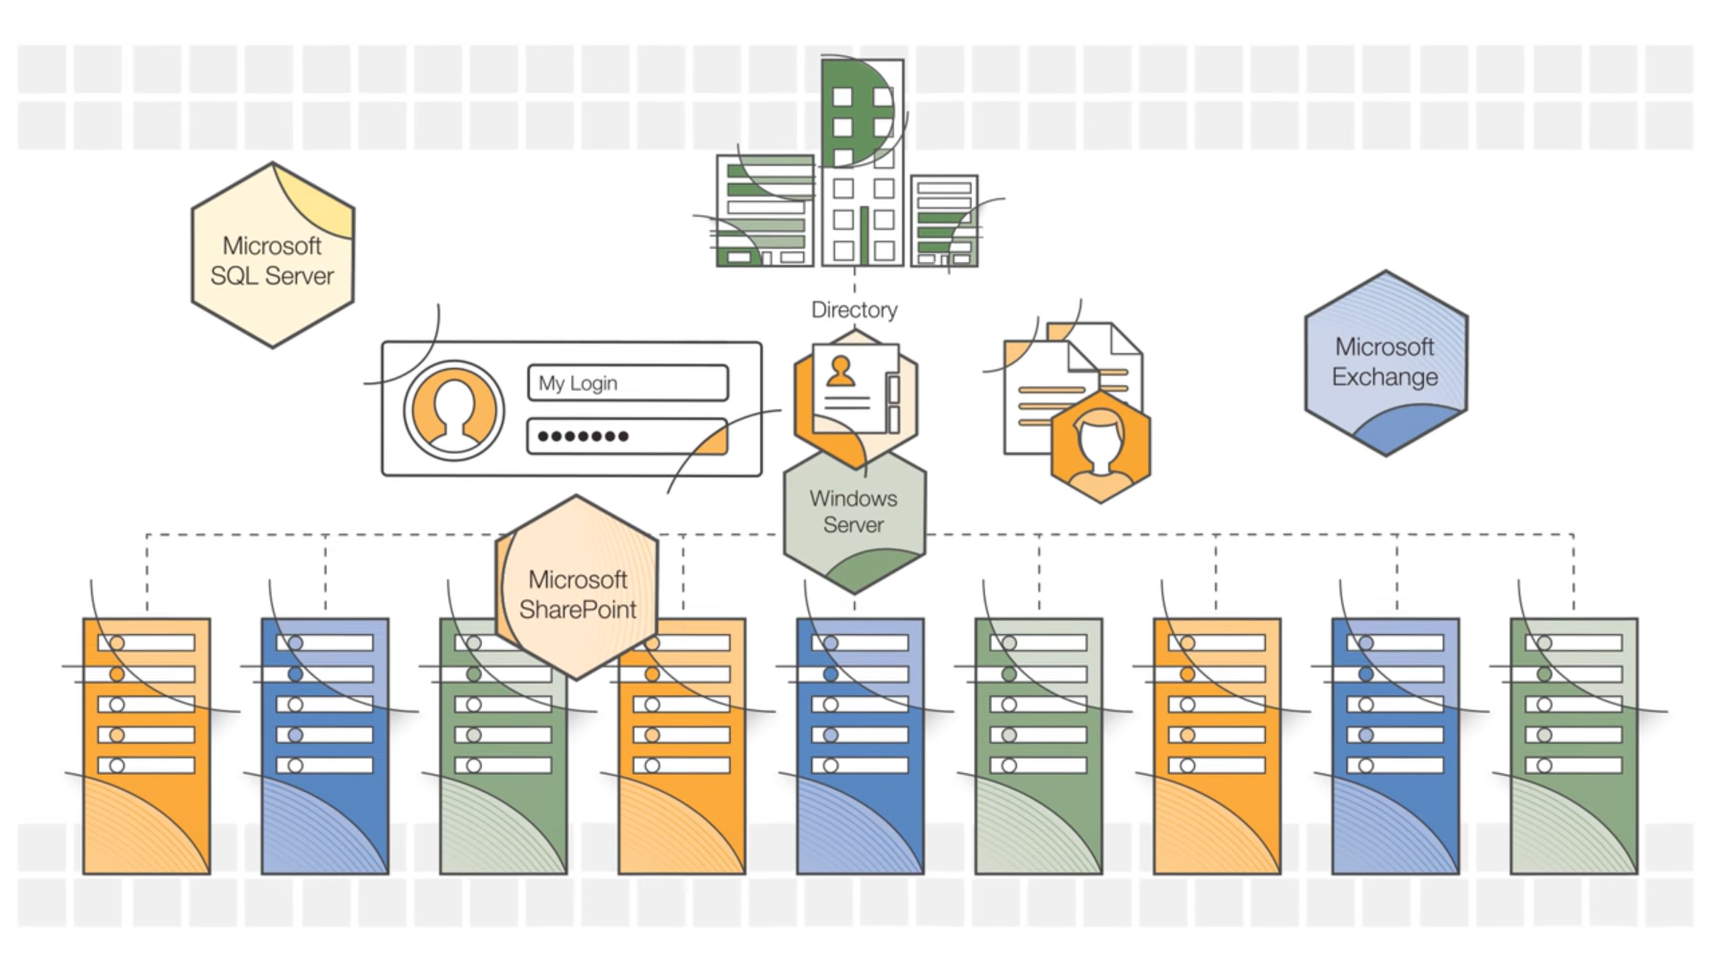

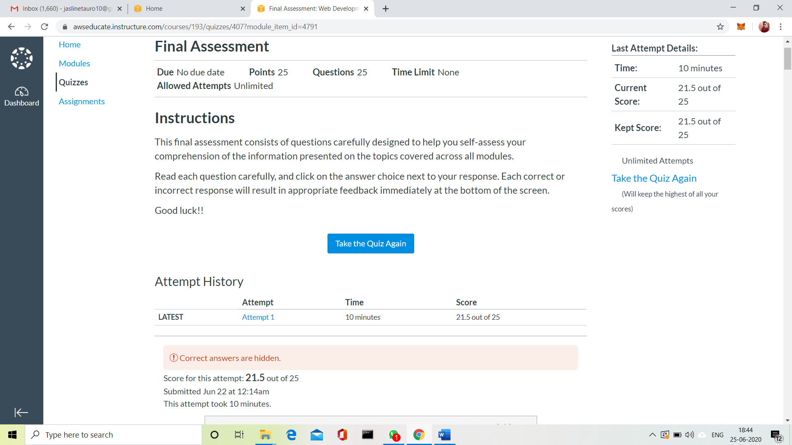

WEBINAR DETAILS:

Today I have attended the webinar on “Why C++, Introduction to OOP and its Features” by Assistant professor Ms. Shruthi Shetty J, CSE department- AIET. The session was very interesting. There was assessment conducted based on the webinar. The test was of MCQ type, there were 6 number of questions of 5 mark each out of which I scored 25.

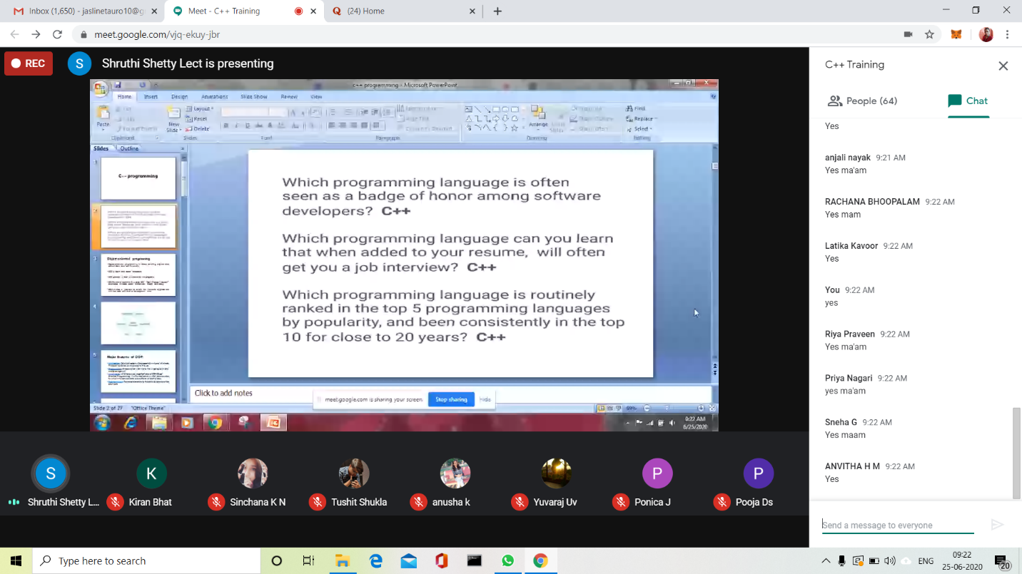

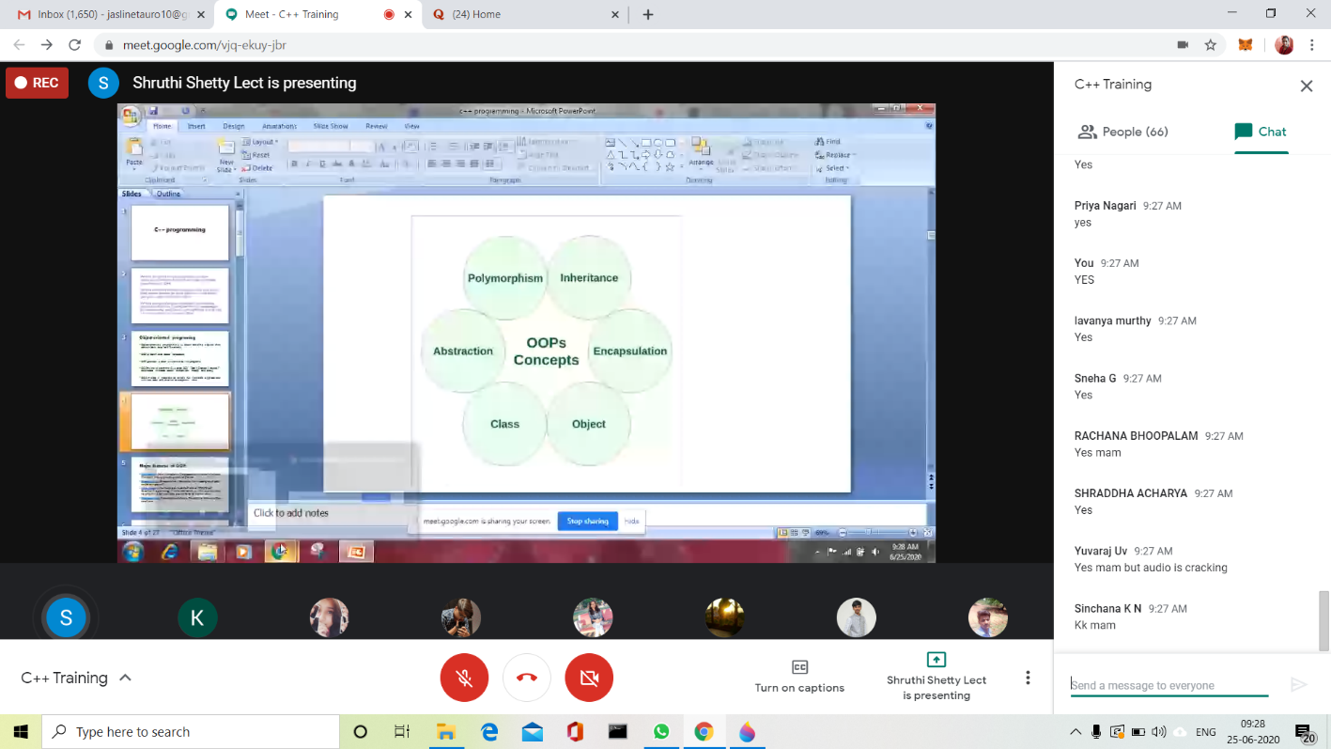

CODING CHALLENGES:

Problem Statement:

Write a C Program to reverse the rows in a 2d Array.

Given a 2D array arr [][] of size M x N integers where M is the number of rows and N is the number of columns. The task is to reverse every row of the given 2D array.

**Example:**

**Input:** arr[][] =  
{ {1, 2, 3},  
{4, 5, 6},  
{7, 8, 9} }

**Output:**  
3 2 1  
6 5 4  
9 8 7

**Input:** arr[][] =  
{ {1, 2},  
{4, 5},  
{7, 8},  
{9, 10} }  
**Output:**  
2 1  
5 4  
8 7  
10 9

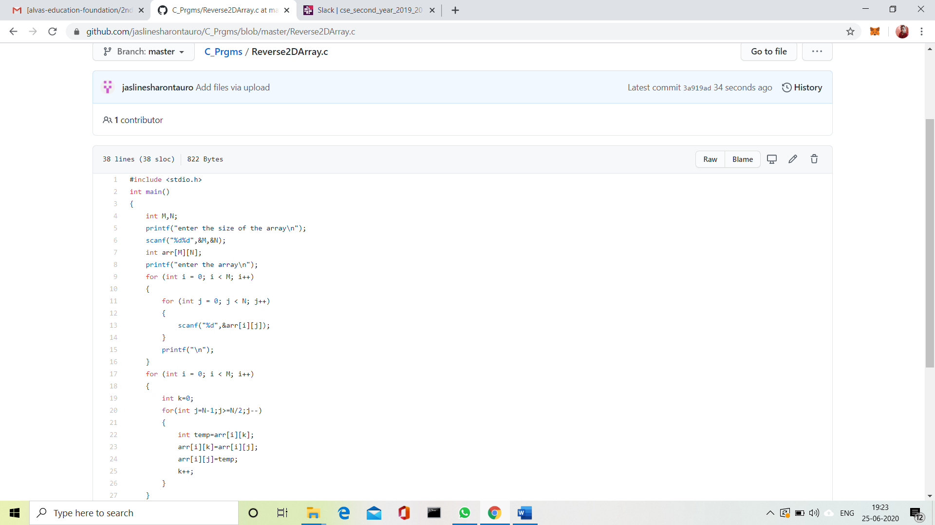

Solution Uploaded in GitHub.